|  |  |
| --- | --- |
| Activity | Data Type |
| Number of beatings from Wife | Discrete |
| Results of rolling a dice | Discrete |
| Weight of a person | Continuous |
| Weight of Gold | Continuous |
| Distance between two places | Continuous |
| Length of a leaf | Continuous |
| Dog's weight | Continuous |
| Blue Color | Categorical |
| Number of kids | Discrete |
| Number of tickets in Indian railways | Discrete |
| Number of times married | Discrete |
| Gender (Male or Female) | Categorical |

**Q1) Identify the Data type for the Following:**

**Q2) Identify the Data types, which were among the following**

**Nominal, Ordinal, Interval, Ratio.**

|  |  |
| --- | --- |
| Data | Data Type |
| Gender | Nominal |
| High School Class Ranking | Ordinal |
| Celsius Temperature | Interval |
| Weight | Ratio |
| Hair Color | Nominal |
| Socioeconomic Status | Ordinal |
| Fahrenheit Temperature | Interval |
| Height | Ratio |
| Type of living accommodation | Ordinal |
| Level of Agreement | Ordinal |
| IQ(Intelligence Scale) | Interval |
| Sales Figures | Interval |
| Blood Group | Nominal |
| Time Of Day | Interval |
| Time on a Clock with Hands | Interval |
| Number of Children | Ratio |
| Religious Preference | Ordinal |
| Barometer Pressure | Interval |
| SAT Scores | Interval |
| Years of Education | Interval |

**Q3) Three Coins are tossed, find the probability that two heads and one tail are obtained?**

**Answer:** Three coins are tossed so the possibility of outcomes will be: HHH, HHT, HTH, THH, TTT, TTH, THT and HTT

The probability of getting two heads and one tail = (interested events / total no of

outcomes) = 3/8 = 37 %

**Q4) Two Dice are rolled, find the probability that sum is**

a) Equal to 1

b) Less than or equal to 4

c) Sum is divisible by 2 and 3

**Answer:** Two Dice are rolled, so the no of outcomes = 6 * 6 = 36

a) When we roll two dice the probability of sum is minimum 2, because it

starts from (1,1)

So the probability that sum is equal to 1 (i.e) Zero

b) The probability that sum is less than or equal to 4

According to above condition the outcomes are (1,1),(1,2),(1,3),(2,1),(2,2)

and (3,1)

So now the probability that sum is less than or equal to 4 = 6/36 =16.66 %

c) The probability that the sum is divisible by 2 and 3

For the above condition the outcomes are: (1,5),(2,4),(3,3),(4,2),(5,1),(6,6)

So now the probability that sum is divisible by 2 and 3 = 6/36 = 16.66%

**Q5) A bag contains 2 red, 3 green and 2 blue balls. Two balls are drawn at random. What is the probability that none of the balls drawn is blue?**

**Answer:** Total number of balls = (2 + 3 + 2) = 7

Let A be the sample space

Then, n(A) = Number of ways of drawing 2 balls out of 7

n(A) = 7 C 2

n(A) = (7×6) / (2×1) = 21

Let E = Event of 2 balls, none of which is blue

∴ n (E) = Number of ways of drawing 2 balls out of (2 + 3) balls

n (E)= 5 C 2

n (E) = (5×4) / (2×1) = 10

∴ P(E) = n(E) /n(A)=10 /21

**Q6) Calculate the Expected number of candies for a randomly selected child**

**Below are the probabilities of count of candies for children (ignoring the nature of the child-Generalized view)**

|  |  |  |
| --- | --- | --- |
| CHILD | Candies count | Probability |
| A | 1 | 0.015 |
| B | 4 | 0.20 |
| C | 3 | 0.65 |
| D | 5 | 0.005 |
| E | 6 | 0.01 |
| F | 2 | 0.120 |
|  |  |  |

Child A – probability of having 1 candy = 0.015.

Child B – probability of having 4 candies = 0.20

**Answer**: Expected number of candies for a randomly selected child

= (1 x 0.015) + (4 x 0.20) + (3 x 0.65) + (5 x 0.005) + (6 x 0.01) + (2 x 0.120)

= 0.015 + 0.8 + 1.95 + 0.025 + 0.06 + 0.24 = 3.09

**Q7) Calculate Mean, Median, Mode, Variance, Standard Deviation, Range & comment about the values / draw inferences, for the given dataset**

**For Points , Score, Weigh**

**Find Mean, Median, Mode, Variance, Standard Deviation, and Range and also Comment about the values/ Draw some inferences.** **Use Q7.csv file**

**Answer: In Python**

Import pandas as pd

df= pd.read_csv('Q7 (2).csv')

df

df.var()

df.describe()

|  |  |  |  |
| --- | --- | --- | --- |
|  | **Points** | **Score** | **Weigh** |
| **Mean** | 3.596563 | 3.217250 | 17.848750 |
| **Median** | 3.695000 | 3.325000 | 17.710000 |
| **Mode** | 3.07 | 3.44 | 17.02 |
| **Variance** | 0.285881 | 0.957379 | 3.193166 |
| **Standard**  **Deviation(s)** | 0.534679 | 0.978457 | 1.786943 |
| **Range** | 2.17 | 3.911 | 8.4 |

**Inference:** Here in this case of different models of cars data, most type of cars have averagepoints of 3.596563 , score of 3.217250 and weigh of 17.848750. Also here in thisscenario the standard deviation is very low in points and score so chances of

presence of outliers in both the case is very low and comparing to weigh there is

little high standard deviation so may be some outliers are present.

Somehow data points in every case have less spread so most of the data points lie

near to the median.

**Q8) Calculate Expected Value for the problem below**

1. The weights (X) of patients at a clinic (in pounds), are

108, 110, 123, 134, 135, 145, 167, 187, 199

Assume one of the patients is chosen at random. What is the Expected

Value of the Weight of that patient?

**Answer:** The weights(X) of patients at a clinic (in pounds) are 108,110, 123, 134, 135, 145, 167, 187 and 199

There are 9 patients and also their weights are different

So the probability of choose each patient = 1/9

Here E(X) - 108,110, 123, 134, 135, 145, 167, 187, 199

P(X) - 1/9, 1/9, 1/9, 1/9, 1/9, 1/9, 1/9, 1/9, 1/9

Expected Value = ∑ (probability x Value)

 ∑ P(x).E(x)

Expected Value = ((1/9) x 108) + ((1/9) x 110) + ((1/9) x 123) + ((1/9) x 134) +

((1/9) x 135) + ((1/9) x 145) + ((1/9) x 167) + ((1/9) x 187) + ((1/9) x 199)

= (1/9) x (108 + 110 + 123 + 134 + 135 + 145 + 167 + 187 + 199)

= (1/9) x (1308) = 145.33

**Q9) Calculate Skewness, Kurtosis & draw inferences on the following data**

**Cars speed and distance**

**Use Q9_a.csv**

**Answer:** import pandas as pd

df= pd.read_csv('Q9_a (1).csv')

df

df['speed']

df['speed'].skew()

df['speed'].kurt()

df['dist']

df['dist'].skew()

df['dist'].kurt()

Skewness of car speed: -0.11750986144663393

Kurtosis of car speed: -0.5089944204057617

Skewness of distance : 0.8068949601674215

Kurtosis of distance: 0 4050525816795765

**Inferences:**

1) For car speed skewness is negative and also the kurtosis is negative,

Which shows that the distribution is more towards left. It means the

distribution is left skewed or negative skewed. Here in negative skewed the

mean is less than the median. As taking kurtosis into consideration it shows that

the distribution has broad peak and thin tail.

2) For the distance travel by the car skewness is positive and also the

kurtosis is positive, which shows that the distribution is more towards right. It

means the distribution is right skewed or positive skewed. Here in

positive skewed the mean is greater than the median. As taking kurtosis

into consideration it shows that the distribution has pointed peak and wide tail.

**SP and Weight(WT)**

**Use Q9_b.csv**

**Answer:** import pandas as pd

a= pd.read_csv('Q9_b.csv')

a

a['SP'].skew()

a['SP'].kurt()

a['WT'].skew()

a['WT'].kurt()

Skewness of SP: 1.6114501961773586

Kurtosis of SP: 2.9773289437871835

Skewness of WT: -0.6147533255357768

Kurtosis of WT: 0.9502914910300326

**Inferences**:

1) For SP skewness is positive and also the kurtosis is positive, which

suggests that the distribution is more towards right. It means the

distribution is right skewed or positive skewed. Here in positive skewed the

mean is greater than the median. As taking kurtosis into consideration it shows

that the distribution has pointed peak and wide tail.

2) For WT skewness is negative and the kurtosis is positive, which

suggests that the distribution is more towards left. It means the distribution is left skewed or negative skewed. Here in negative skewed the mean is

less than the median.

**Q10) Draw inferences about the following boxplot & histogram**



**Inference:** From this above Histogram and Box plot, it shows that the distribution hasoutliers at the end ( (i.e) in histogram tail side and in box plot at in upperextreme). The distribution is Positive Skewed or Right Skewed.

**Q11) Suppose we want to estimate the average weight of an adult male in Mexico. We draw a random sample of 2,000 men from a population of 3,000,000 men and weigh them. We find that the average person in our sample weighs 200 pounds, and the standard deviation of the sample is 30 pounds. Calculate 94%,98%,96% confidence interval?**

**Answer:** Here total no of sample mean (n) = 2000

The average weight of person in sample (X̅) = 200

Standard deviation of sample () = 30

Confidence Interval = For 94% of CI value Z score = 1.89

Confidence interval for 94% = 200 ± (1.89 x (30/))

=198.73 to 201.27

For 98% of CI value Z score = 2.33

Confidence interval for 98% = 200 ± (2.33 x (30/))

=198.43 to 201.56

For 96% of CI value Z score = 2.06

Confidence interval for 96% = 200 ± (2.06 x (30/))

=198.62 to 201.38

**In Python :**

from scipy import stats

import numpy as np

from math import sqrt

**1.** ci_94 = stats.norm.interval(0.94,200,scale = (30/sqrt(2000)))

print(‘Weight at 94% confidence interval is:’,np.round(ci_94,4))

**Weight confidence interval is: [198.7383 201.2617]**

**2**. ci_98 = stats.norm.interval(0.98,200,scale = (30/sqrt(2000)))

print(‘Weight at 98% confidence interval is:’,np.round(ci_98,4))

**Weight at 98% confidence interval is: [198.4394 201.5606]**

**3**. ci_98 = stats.norm.interval(0.98,200,scale = (30/sqrt(2000)))

print(‘Weight at 98% confidence interval is:’,np.round(ci_98,4))

**Weight at 96% confidence interval is: [198.6223 201.3777]**

**Q12) Below are the scores obtained by a student in tests**

**34,36,36,38,38,39,39,40,40,41,41,41,41,42,42,45,49,56**

1. **Find mean, median, variance, standard deviation.**

**Answer:** import pandas as pd

import statistics as sts

st = [34,36,36,38,38,39,39,40,40,41,41,41,41,42,42,45,49,56]

sts.mean(st)

sts.median(st)

round(sts.variance(st),4)

round(sts.stdev(st),4)

**Mean = 41**

**Median = 40.5**

**Variance = 25.5294**

**Standard Deviation =5.0527**

1. **What can we say about the student marks?**

**Answer:** The student score 41 mark most of the time. He scores average 41 mark.

**Q13) What is the nature of skewness when mean, median of data are equal?**

**Answer:**  The Nature of skewness is zero.

**Q14) What is the nature of skewness when mean > median ?**

**Answer:**  When mean > median, the nature of skewness is Positive. It means Right skewed.

**Q15) What is the nature of skewness when median > mean?**

**Answer:** When the median > mean, the nature of skewness is Negative. It means left skewed.

**Q16) What does positive kurtosis value indicates for a data ?**

**Answer:** Positive kurtosis indicates that the distribution is peaked and possess thick tails. It means most of the data located on the tail side. And it also indicates that the distribution has heavier tails than the normal distribution.

**Q17) What does negative kurtosis value indicates for a data?**

**Answer:** Negative kurtosis value for a data indicates that the distribution has lighter tails than the normal distribution.

**Q18) Answer the below questions using the below boxplot visualization.**



1. **What can we say about the distribution of the data?**

**Answer:** Most of the data distributed between of “10 to 18.3”.

1. **What is nature of skewness of the data?**

**Answer:** Nature of skewness of the data is Negative Skewness. It means it is left skewed.

1. **What will be the IQR of the data (approximately)?**

**Answer:** IQR = 8.2 (approximately).

50 % of data lies in between IQR range.  
  
  
**Q19) Comment on the below Boxplot visualizations?**



**Draw an Inference from the distribution of data for Boxplot 1 with respect Boxplot 2.**

**Q 20) Calculate probability from the given dataset for the below cases**

**Data _set: Cars.csv**

Calculate the probability of MPG of Cars for the below cases.

MPG <- Cars$MPG

1. P(MPG>38)

b. P(MPG<40)

c. P (20<M)PG<50)

**In Python:** import pandas as pd

df = pd.read_csv('Cars (1).csv')

df

df.head()

|  |  |  |  |  |  |
| --- | --- | --- | --- | --- | --- |
|  | HP | MPG | VOL | SP | WT |
| 0 | 49 | 53.700681 | 89 | 104.185353 | 28.762059 |
| 1 | 55 | 50.013401 | 92 | 105.461264 | 30.466833 |
| 2 | 55 | 50.013401 | 92 | 105.461264 | 30.193597 |
| 3 | 70 | 45.696322 | 92 | 113.461264 | 30.632114 |
| 4 | 53 | 50.504232 | 92 | 104.461264 | 29.889149 |
|  |  |  |  |  |  |

df['MPG'].mean() : 34.422075728024666

df['MPG'].std():9.131444731795982

1. P(MPG>38)

from scipy import stats

1-stats.norm.cdf(38,34.42,9.13)

**0.34748702501304063**

1. P(MPG<40)

stats.norm.cdf(40,34.42,9.13)

**0.7294571279557076**

**c.** P(20<M)PG<50)

stats.norm.cdf(50,34.42,9.13)-stats.norm.cdf(20,34.42,9.13)

**0.89891778245492**

|  |  |  |  |  |
| --- | --- | --- | --- | --- |
|  |  |  |  |  |

**Q 21) Check whether the data follows normal distribution**

1. **Check whether the MPG of Cars follows Normal Distribution**

**Dataset: Cars.csv**

import matplotlib.pyplot as plt

plt.boxplot(df['MPG'])

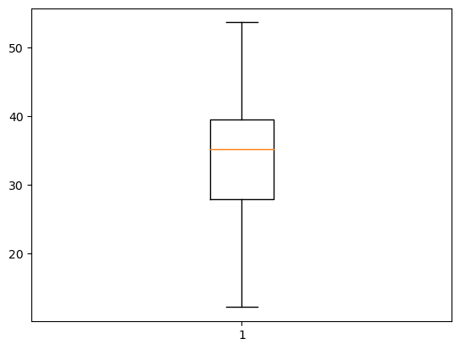

plt.hist(df['MPG'])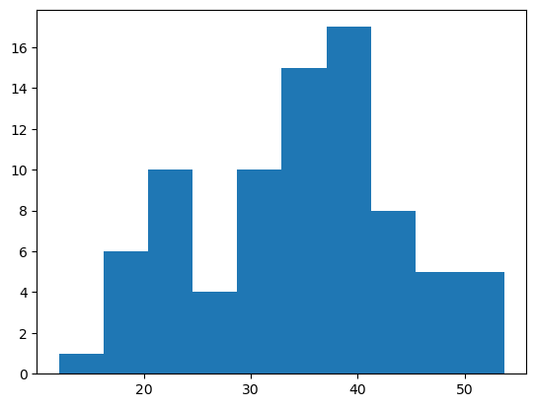In [ ]:

**Answer:** From the above Box plot and Histogram we can say the MPG of Cars follows a Normal Distribution.

1. **Check Whether the Adipose Tissue (AT) and Waist Circumference(Waist) from wc-at data set follows Normal Distribution**

**Dataset: wc-at.csv**

**Answer:** import pandas as pd

import numpy as np

import matplotlib.pyplot as plt

ab=pd.read_csv('wc-at.csv')

ab

plt.boxplot(ab['AT'])

plt.show()

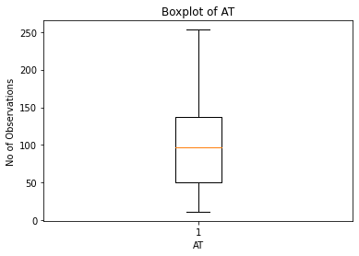

plt.hist(ab['AT'])

plt.show()

In [11]: 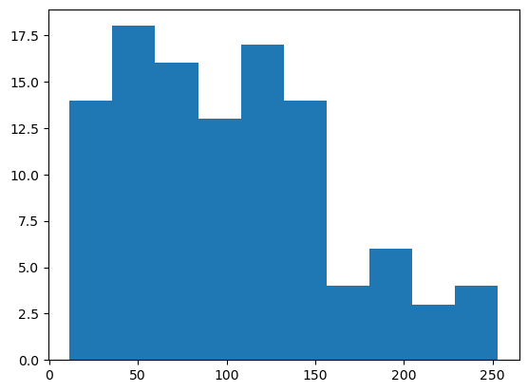

plt.boxplot(ab['Waist']

plt.show()

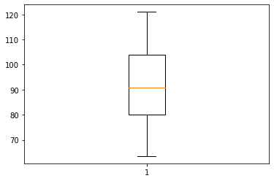

plt.hist(ab['Waist'])

plt.show()

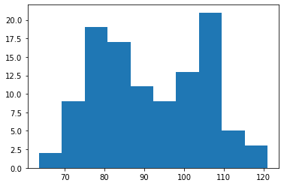In [8]:

**Answer:** From the above histogram and box plot for both AT and Waist of wcat data set shows that both AT and Waist follows Normal Distribution.

**Q 22) Calculate the Z scores of 90% confidence interval,94% confidence interval, 60% confidence interval**

**Answer**: 1) from scipy import stats

stats.norm.ppf(0.95)

**Z score for 90% confidence interval is 1.6448536269514722**

2) from scipy import stats

stats.norm.ppf(0.97)

**Z score for 94% confidence interval is 1.8807936081512509**

3) from scipy import stats

stats.norm.ppf(0.80)

**Z score for 60% confidence interval is 0.8416212335729143**

**Q 23) Calculate the t scores of 95% confidence interval, 96% confidence interval, 99% confidence interval for sample size of 25**

**Answer :** 1) from scipy import stats

stats.t.ppf(0.975,24)

**t score for 95% confidence interval for sample size 25 is 2.0638985616280205**

2)from scipy import stats

stats.t.ppf(0.98,24)

**t score for 96% confidence interval for sample size 25 is 2.1715446760080677**

3)from scipy import stats

stats.t.ppf(0.995,24)

**t score for 99% confidence interval for sample size 25 is 2.796939504772804**

**Q 24) A Government company claims that an average light bulb lasts 270 days. A researcher randomly selects 18 bulbs for testing. The sampled bulbs last an average of 260 days, with a standard deviation of 90 days. If the CEO's claim were true, what is the probability that 18 randomly selected bulbs would have an average life of no more than 260 days**

**Hint:**

**rcode 🡪 pt(tscore,df)**

**df 🡪 degrees of freedom**

**Answer:** Population mean,µ = 270

Sample size, n = 18

Sample mean, x̅ = 260

Standard deviation, s =90

t score = (x̅- µ)/(s/sqrt(n))

=(260-270)/(90/sqrt(18))

= -10/21.23

= -0.47

df= degrees of freedom

n-1 = 18-1= 17

Probability

pt(tscore,df)

pt(-0.47,17)

**Answer:** 0.3221639